Austin Johns

Index View and Creation

**Query to combine tables:**

use AdventureWorks2016CTP3;

go

create view PersonView

with SchemaBinding

as

select e.BusinessEntityID,

p.Firstname,

p.Lastname,

e.JobTitle,

e.Gender

from HumanResources.Employee e,

Person.Person p

where e.BusinessEntityID = p.BusinessEntityID;

**Query to get runtime and view result:**

declare @EndTime datetime

select @StartTime = getdate()

select * from PersonView;

select @EndTime = getdate()

select DateDiff(MS, @StartTime, @EndTime) as [Duration in ms]

**The runtime I got was 74 milliseconds.**

**First index query for the view created:**

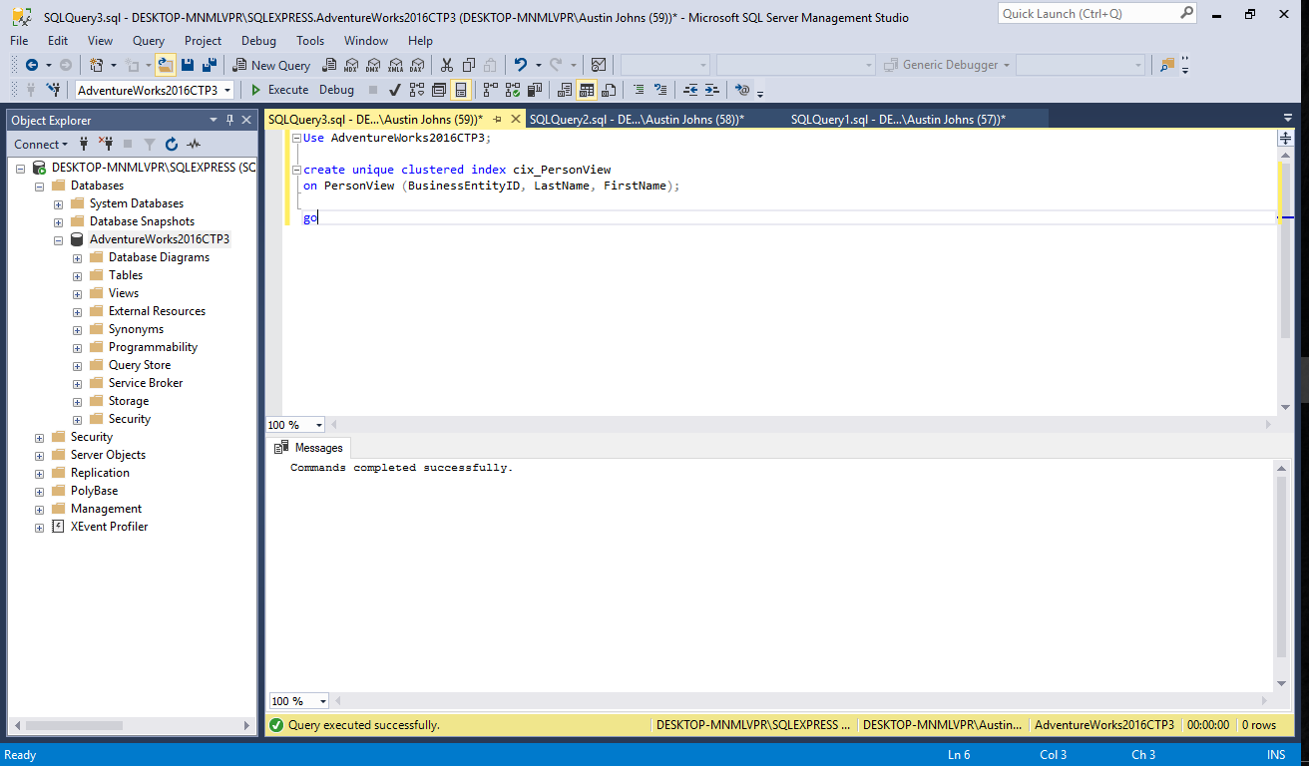

**Query to get time for query:**

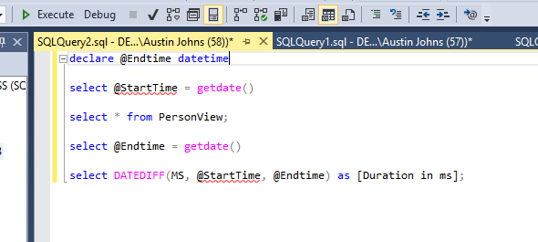

The time I received was 93 milliseconds, which is longer than the previous query without the index created.

**For this index, I created a nonclustered version of the original view to see how the runtime would change:**

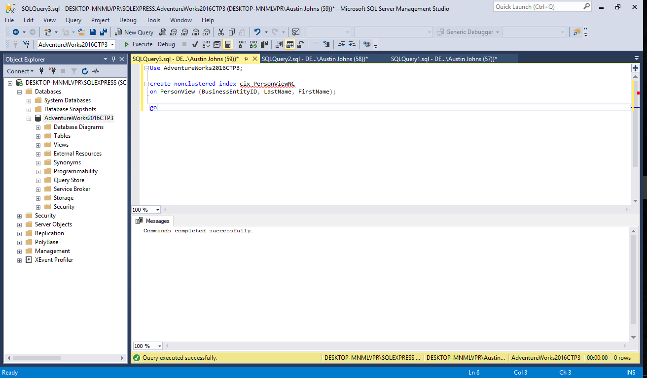

**To find the runtime of the nonclustered index:**

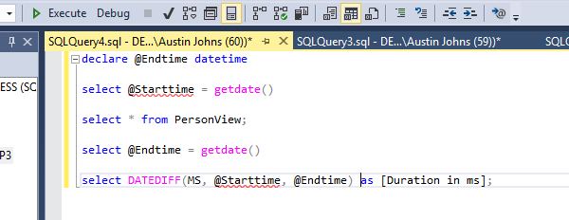

The nonclustered index returned a runtime of 62 milliseconds, which is substantially shorter than the clustered index.